From the Minister – Rev Dr Allan Vint

Greenhouse Thoughts and Growing Faith
The tomatoes in the manse greenhouse are off to a slow start this year—maybe they’ll ripen just in time for the annual horticultural show! While the plants are now growing well and beginning to flower, there was a spell when it seemed like everything had stalled. I couldn’t help but wonder what had gone wrong. Were they getting enough water? Was the greenhouse too hot or too cold? Perhaps the soil was lacking in nutrients. Whatever the issue, things are now back on track—and it’s a joy to see new growth taking shape.

Over the past few weeks, many of you have taken part in our church health survey. I’ve recently received the results, and I’m delighted to share that there is much to be encouraged about. There are many signs of strength and vitality in our church family, and that’s something to celebrate.

At the same time, the survey also highlights areas where we can grow further—and one key focus is how we each continue to grow as disciples of Jesus. This is about deepening our relationship with God through Christ. That growth can take many different forms, depending on how God has uniquely created us. For many, it will involve prayer or reading Scripture—those traditional yet powerful ways we connect with God. For others, it might be through worship, receiving the sacraments, sitting in quiet reflection, or spending time in the beauty of creation. And for most of us, it will likely be a mix of all these things and more.

The how matters less than the what: our ongoing personal transformation into the likeness of Christ. This is the heart of our calling—not just to know life in Christ, but to live it in all its fullness here and now.

So let’s continue to grow together. Let’s encourage one another. And let’s keep reaching for the good fruit that God longs to bring to life in each one of us.
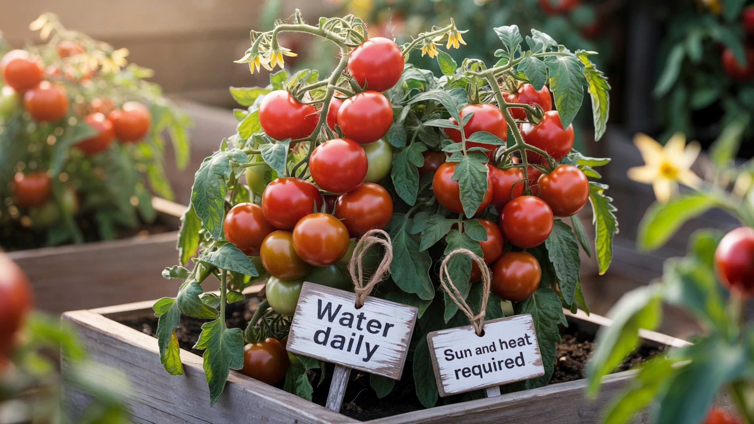

William Gibson: Our Student minister on summer placement
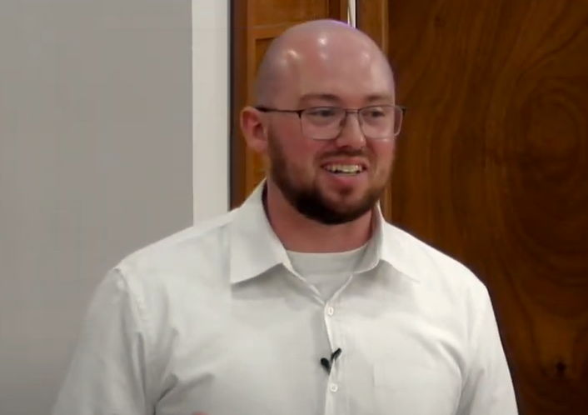
A Church of Scotland Ministry Candidate in their 20s? Maybe pigs can fly. My name is William Gibson, and I am currently completing my second ministry placement at Mauchline and Sorn with one day a week at Glasgow City Mission. I was raised in the Kirk in Ayrshire but at the age of 9 my family and I left. To make a long story short I ended up in independent evangelical churches throughout my teens and early twenties finding myself drawn in by the sizable youth groups, lively worship music, and passionate preaching.
However, as with most young people entering adulthood, I began to question many of the certainties that I had been taught. The church in Glasgow that I attended at the time had little room for doubt and so I found myself pushed out, still curious about faith but without a community. Eventually, I ended up back in the fold of the Kirk and soon after settling in I started considering ministry. In 2023 I began the application process while in my 3rd year of a Theology degree at the University of Glasgow. Now I’ve found myself here in Mauchline and Sorn after completing my first placement at Barrhead St Andrew’s. I am also working on my PhD while on placements. Throughout the application process and initial training, ministry has felt less like a career choice and more like something I couldn’t not do. As one of my favourite songs says, “the Holy Ghost keeps haunting me”.
While on my placement here I hope to grow in faith and in my sense of what God is calling me to in ministry. Through sharing the good news of God’s unconditional love shown to us in the person of Jesus Christ, praying for and visiting members of the congregations, and hopefully encouraging and supporting people in their faith and lives. I also hope to listen and learn, to hear the stories of members of the congregations who have been here and followed Jesus for longer than I’ve been alive, to participate in and engage with the wider community and listen to their concerns and hopes for Mauchline and Sorn, and to see how God is already at work here in 2025. Because he certainly is at work here even where we least expect it.

Annette, Janice and everyone involved in organising the annual Strawberry Teas event would like to thank all shops, businesses, local schools and everyone who came along to the hall on the day for their support
.
We would also like to thank Mossgiel Milk for donating the cream and A & A Spittal for donating half of the strawberries.

We were delighted to support Ellisland Court, Mauchline Primary School and Mauchline Early Learning and Childcare Centre and thanks to the generosity of our community we were able to hand over £300 to each of the three very worthwhile causes.

Thank you once again for the support and look forward to seeing you again next year

Mauchline Church Mens Club
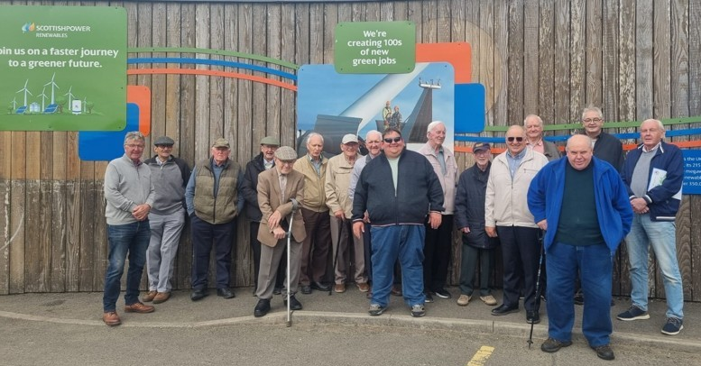

Sixteen members of the Men’s Club had an enjoyable visit to Whitelee Windfarm Visitor Centre on our summer outing, followed by lunch at Fenwick Hotel. Our new session starts on Wednesday 10th September 2025 with a games night in Mauchline Church hall starting at 7pm.
Willie Jardine
Calling All Surfers

If you have ever wondered how important our online activies are then below you will see two sets of information. The first chart if for our church YouTube channel. The second set of graphs is for our Facebook page. It is clear just how vital this new interactive ministry is as we seek to reach out beyond the walls of our wonderful church. Please continue to pray for all those who give of their time and talents to stream our church services and create content for our online posts.

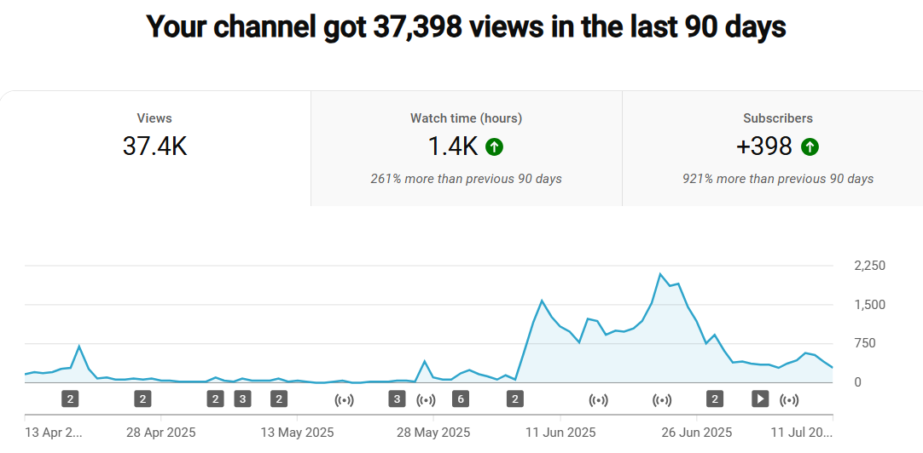
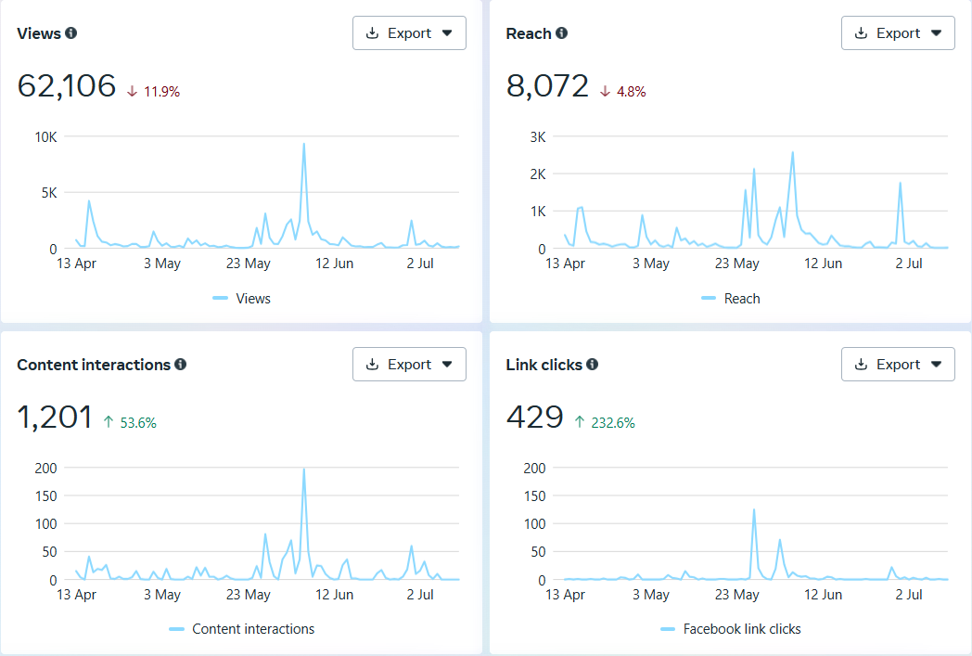

Treasurer’s Report

Holy Fair Teas brought in £1,768
Gift Aid reclaimed was £10,803
Christian Aid collection was £625
Extra expenditure items for May and June were as follows:
Organ tuning: £367
Accessible Toilet payments: £24,700
Upgrade to sockets in vestry: £912
I would like to thank everyone who contributes either on a regular or intermittent basis.
Yours in Christ Mark Crawshaw Treasurer

Food bank
I would like to say a big thank you to those who regularly give to the Food Bank and to those who contribute on special occasions.
However, can I urge you not to forget our local food bank.
The volunteers there work very hard to ensure that folk don't go without essentials.
Even just one extra item in your weekly shop would make such a difference.
I am also aware that some of you donate whilst inside the supermarket and that is great.
There's a box for donations in the Clarke Memorial Vestibule just behind the computer area. Items of dried/tinned foods, diluting juice, toiletries, including toilet rolls would be very welcome.Thank you,
Sheena

Who’s Who & Where
Minister Rev Dr Allan Vint, Mail: mailto:avint@churchofscotland.org.uk
Newsletter Editor: Mr Jim Beck, Mail: mailto:mauchlineparish@yahoo.com

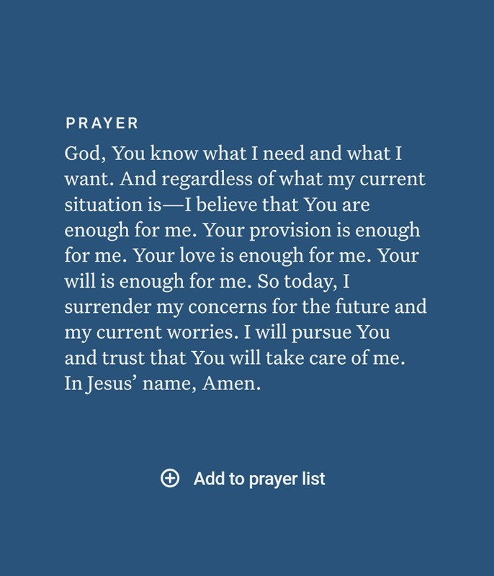

Thank you to everyone who recently took part in our church health survey. Over 30 of you completed the questionnaire, and your honest responses have given us a helpful snapshot of how we're doing as a church family.

The survey we used is part of something called Natural Church Development (NCD), which looks at eight key areas of church life—things like worship, small groups, serving, and how we grow in our faith. Every church has areas of strength and areas where there’s room to grow, and this survey helps us identify both.

Looking at our results, one thing is clear: many of you are really valuing our Sunday worship services. That’s wonderful to hear! It means our time together in worship is meaningful and encouraging.

The area where we scored lowest is something called Passionate Spirituality. That’s about how we're growing in our personal relationship with God—through prayer, reading the Bible, and living out our faith day by day. This isn’t a criticism—think of it more like discovering which spiritual "muscle" needs a bit more exercise.

The exciting news is that we’ve made progress in every single area since the last survey two years ago—including this one! That shows growth is already happening, and we’re on the right path.

Over the coming months, we’ll be creating more ways to help us grow spiritually, both as individuals and together as a church. So let’s keep encouraging one another as we take these next steps. Well done, everyone—and thank you again for being part of this journey. Let’s keep moving forward together as we build Christ’s kingdom here in our congregation and community.. Allan

