.Greenhouse Thoughts and Growing Faith

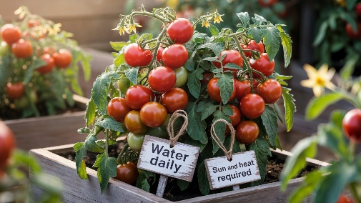
The tomatoes in the manse greenhouse are off to a slow start this year—maybe they’ll ripen just in time for the annual horticultural show! While the plants are now growing well, there was a spell when it seemed like everything had stalled. I couldn’t help but wonder what had gone wrong. Were they getting enough water? Was the greenhouse too hot or too cold? Perhaps the soil was lacking in nutrients. Whatever the issue, things are now back on track—and it’s a joy to see new growth taking shape.

Over the past few weeks, we have had a church health survey. I’ve recently received the results, and I’m delighted to share that there is much to be encouraged about. There are many signs of strength and vitality within our church family, and that’s something to celebrate.

At the same time, the survey also highlights areas where we can grow further—and one key focus is that we each continue to grow as disciples of Jesus. This is about deepening our relationship with God through Christ. That growth can take many different forms, depending on how God has uniquely created us.

The how matters less than the what: our ongoing personal transformation into the likeness of Christ, where we can now his life, his love and the transformation that he can bring to us one of us. I want to encourage us all to grow – to grow in grace and to become the person God always meant us to be. I can happen – but we need to be willing. Is that you? Are you ready to know life in all its fullness through Jesus? Rev Dr Allan Vint

William Gibson: Our Student minister on summer placement
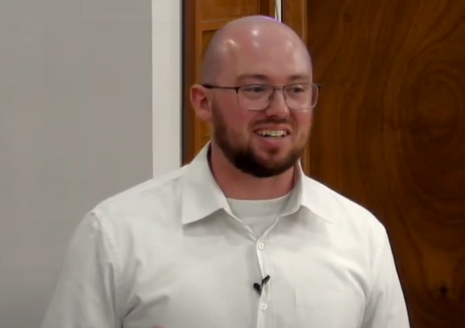
My name is William Gibson, and I am currently completing my second ministry placement at Mauchline and Sorn with one day a week at Glasgow City Mission.
I was raised in the Kirk in Ayrshire but at the age of 9 my family and I left. To make a long story short I ended up in independent evangelical churches throughout my teens and early twenties finding myself drawn in by the sizable youth groups, lively worship music, and passionate preaching.
However, as with most young people entering adulthood, I began to question many of the certainties that I had been taught. Eventually, I ended up back in the fold of the Kirk and soon after settling in I started considering ministry. In 2023 I began the application process while in my 3rd year of a Theology degree at the University of Glasgow. Now I’ve found myself here in Mauchline and Sorn after completing my first placement
While on my placement here I hope to grow in faith and in my sense of what God is calling me to in ministry. Through sharing the good news of God’s unconditional love shown to us in the person of Jesus Christ, praying for and visiting members of the congregations, and hopefully encouraging and supporting people in their faith and lives. I also hope to listen and learn, to hear the stories of members of the congregations who have been here and followed Jesus for longer than I’ve been alive, to participate in and engage with the wider community and listen to their concerns and hopes for Mauchline and Sorn, and to see how God is already at work here in 2025. Because he certainly is at work here even where we least expect it.


Annette, Janice and everyone involved in organising the annual Strawberry Teas event would like to thank all shops, businesses, local schools and everyone who came along to the hall on the day for their support
We would also like to thank Mossgiel Milk for donating the cream and A&A Spittal for donating half of the strawberries.
We were delighted to support Ellisland Court, Mauchline Primary School and Mauchline Early Learning and Childcare Centre and thanks to the generosity of our community we were able to hand over £300 to each of the three very worthwhile causes.
Thank you once again for the support and look forward to seeing you again next year

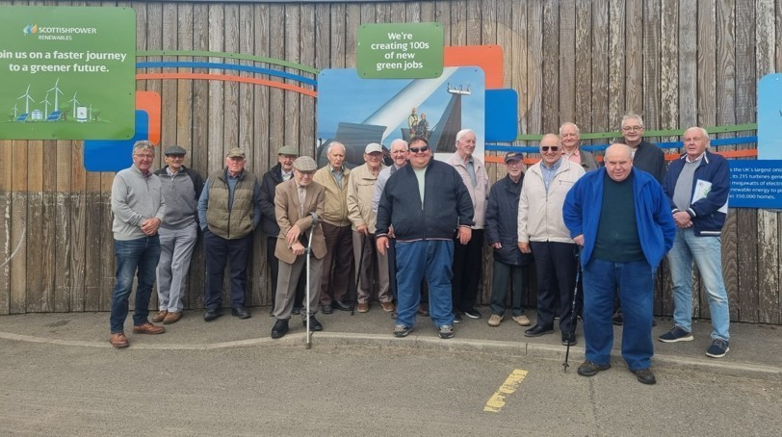

Sixteen members of the Men’s Club had an enjoyable visit to Whitelees Windfarm Visitor Centre on our summer outing, followed by lunch at Fenwick Hotel. Our new session starts on Wednesday 10th September 2025 with a games night in Mauchline Church hall starting at 7pm. New members are always welcome
Willie Jardine
Food bank
I would like to say a big thank you to those who regularly give to the Food Bank and to those who contribute on special occasions.
However, can I urge you not to forget our local food bank.
The volunteers there work very hard to ensure that folk don't go without essentials. Even just one extra item in your weekly shop would make such a difference.

I am also aware that some of you donate whilst inside the supermarket and that is great .There's a box for donations in the Clarke Memorial in the church Vestibule just behind the computer area. Items of dried/tinned foods, diluting juice, toiletries, including toilet rolls would be very welcome. Thank you, Sheena

Church Works

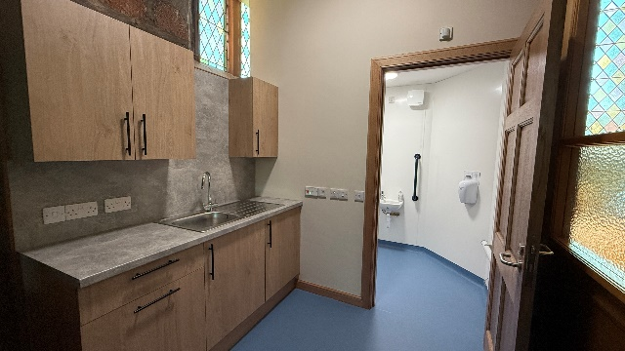
I am delighted to report that we have completed phase 1 of the planned works in the church. This has included the provision of a new accessible toilet, a small tea making area, a new gallery doorway, repainting of the stairwells and installation of a new handrail. It has certainly made the church building more functional, tidier and safer. Many thanks to everyone who helped to make this works possible with their kind donations. Many thanks to CARS for their help in securing works on the cobbled area at the church hall and in the planned works to the cemetery wall at Loudoun Street.

Facebook: https://www.facebook.com/Mauchline.Sorn
Youtube: https://www.youtube.com/@mandschurches
Website: https://church.mauchline.info/

