2024

From the Minister – Rev Dr Allan Vint
In my thinking, I often reflect on the past to help my understanding of the present and the prospects for the future. History is a great teacher, not only of what has happened previously, but also of the lessons we need to learn.

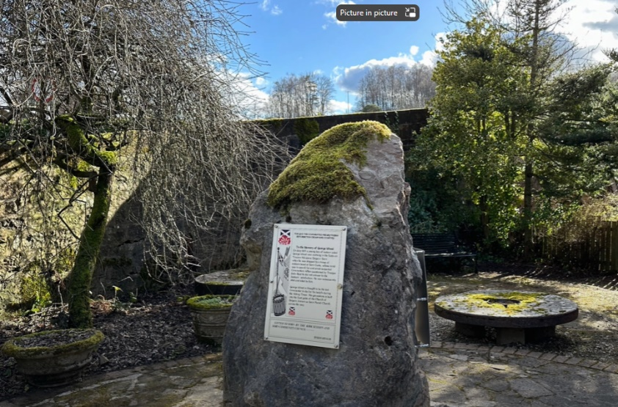
In recent weeks, it was a great privilege to be involved in the unveiling of a memorial in Sorn to two individuals involved in the story of covenanting – Rev Alexander Peden and George Wood. The video of the tragic story of George Wood can be viewed online at https://youtu.be/SW0M77l89og The sorry tale should remind us of how our religious freedoms came at a price and should never be taken for granted. Today there are many forces at work in our society who do not want our children to know the Christian story. Of course, it is a story rich in teaching values and ethics, along with the essential principles of living a good, productive and agreeable life. This is not to mention the pointers it gives to receive the inner strength, guidance and hope that so many today crave. So, what might be the outcome of a society where Christian principles and actions are left behind? A more selfish way of being? A society where everyone makes up their own rules for what is right and good? A society where politicians determine what is ethical and where the boundaries of right and wrong exist? Sadly, we are beginning to see this reality begin to emerge.


I recently went to have a closer look at the old Ballochmyle Creamery (some also call it the ‘Plastic factory’). It was a sad sight to witness the terrible demise of this once beautiful location. https://youtu.be/r0BtcnScxVQ It also stands as witness to what happens when we stop looking after what we have – when what is there is just let go. Some have suggested that we are now in an era of a Post Christian society – where the once treasured things of church and faith are in the process of being ignored and forgotten (certainly fewer young adults know much about the Bible and its contents and a great number of adults never ‘darken the door of the church’).

I want to take this opportunity as we move out of the cold and dark of winter into the new life of Spring to consider how we might truly value our Christian heritage and how we might, with renewed determination, hold fast to the truths passed down the generations in God’s word. As we approach Easter with its message of God’s triumph over the forces of darkness through Jesus, let’s work and pray with vigour that God will again be honoured and glorified in this part of his precious world. Let’s pray for a spiritual revival.

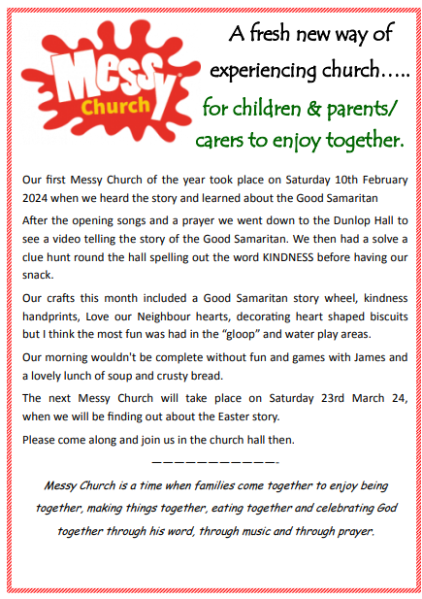
Messy Church

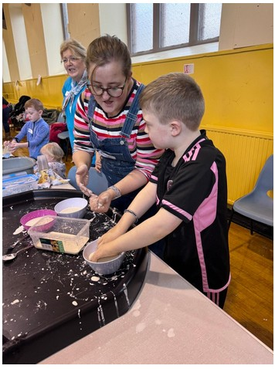
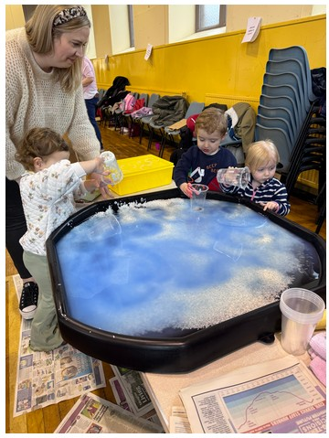

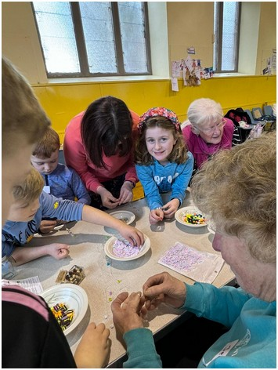
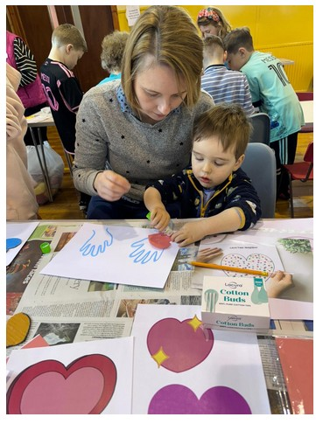

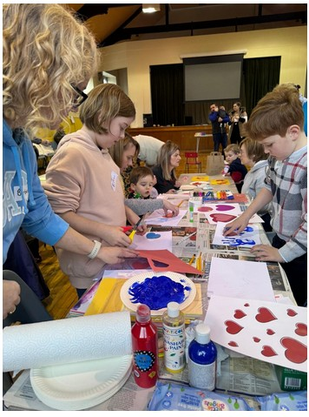

Marie Curie Daffodil Teas
Annette, Janice & the folks involved in organising the Marie Curie Daffodil Teas would like to thank everyone who supported the event in any way.
Special thank you to the House Captains and Vice Captains from Mauchline Primary School who came along to help on the day.
The magnificent sum of £700 has been sent to the charity.

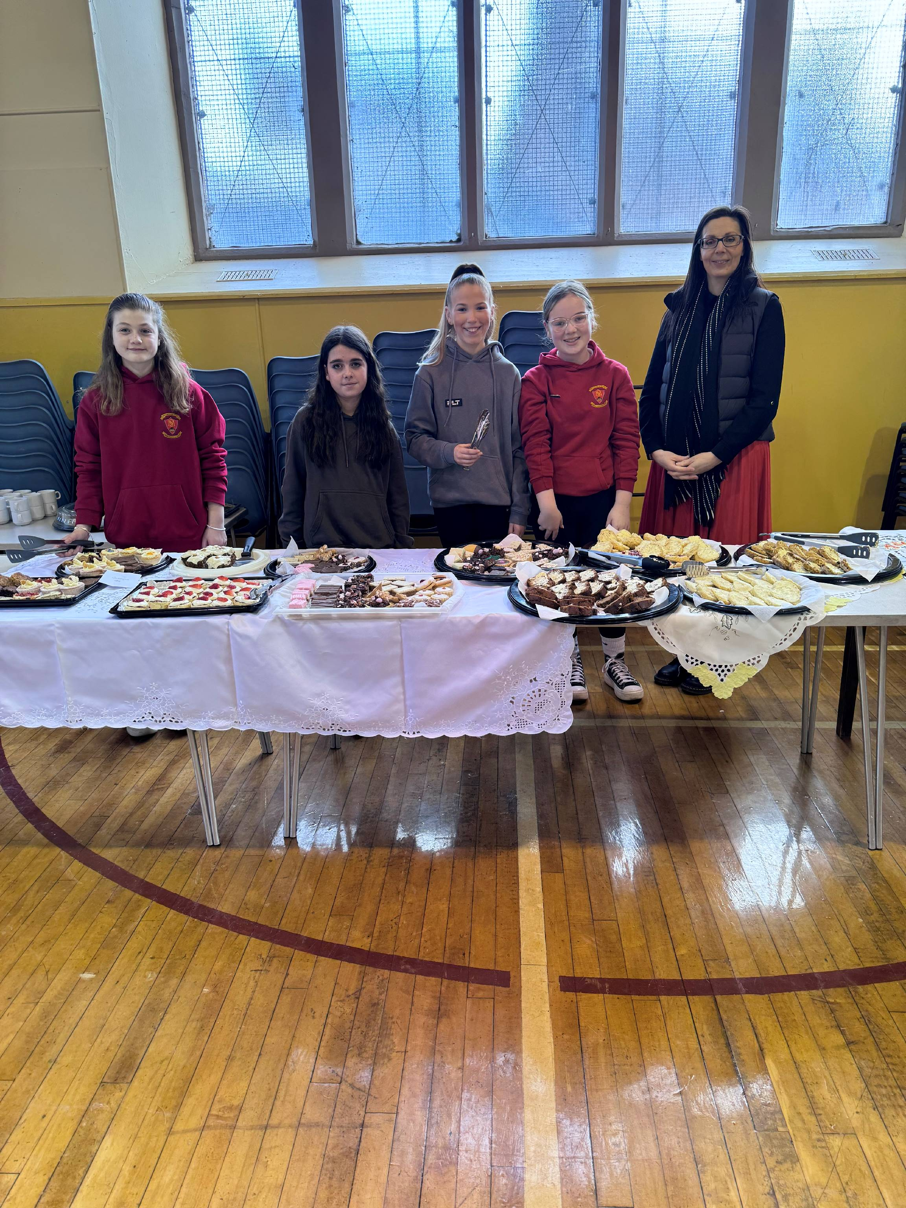


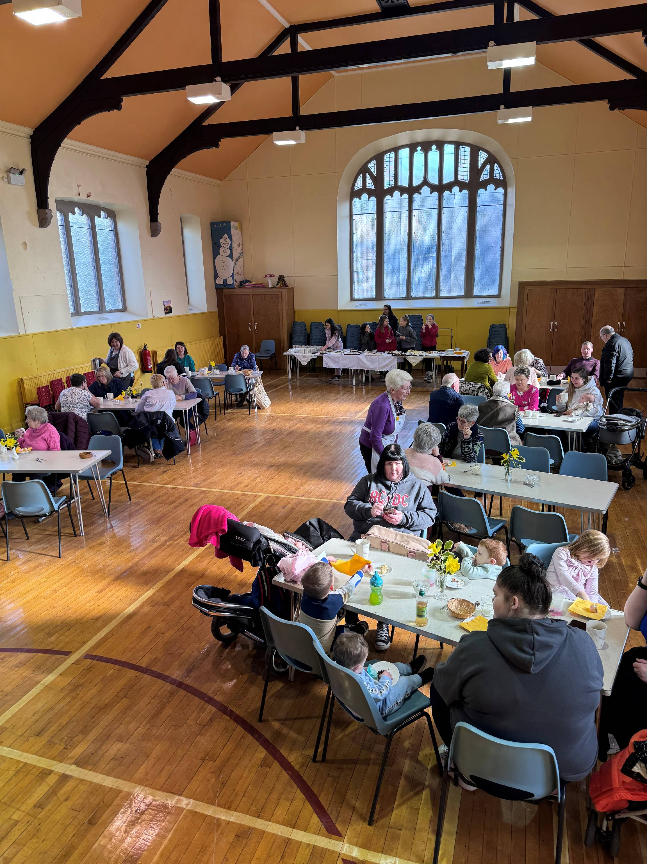

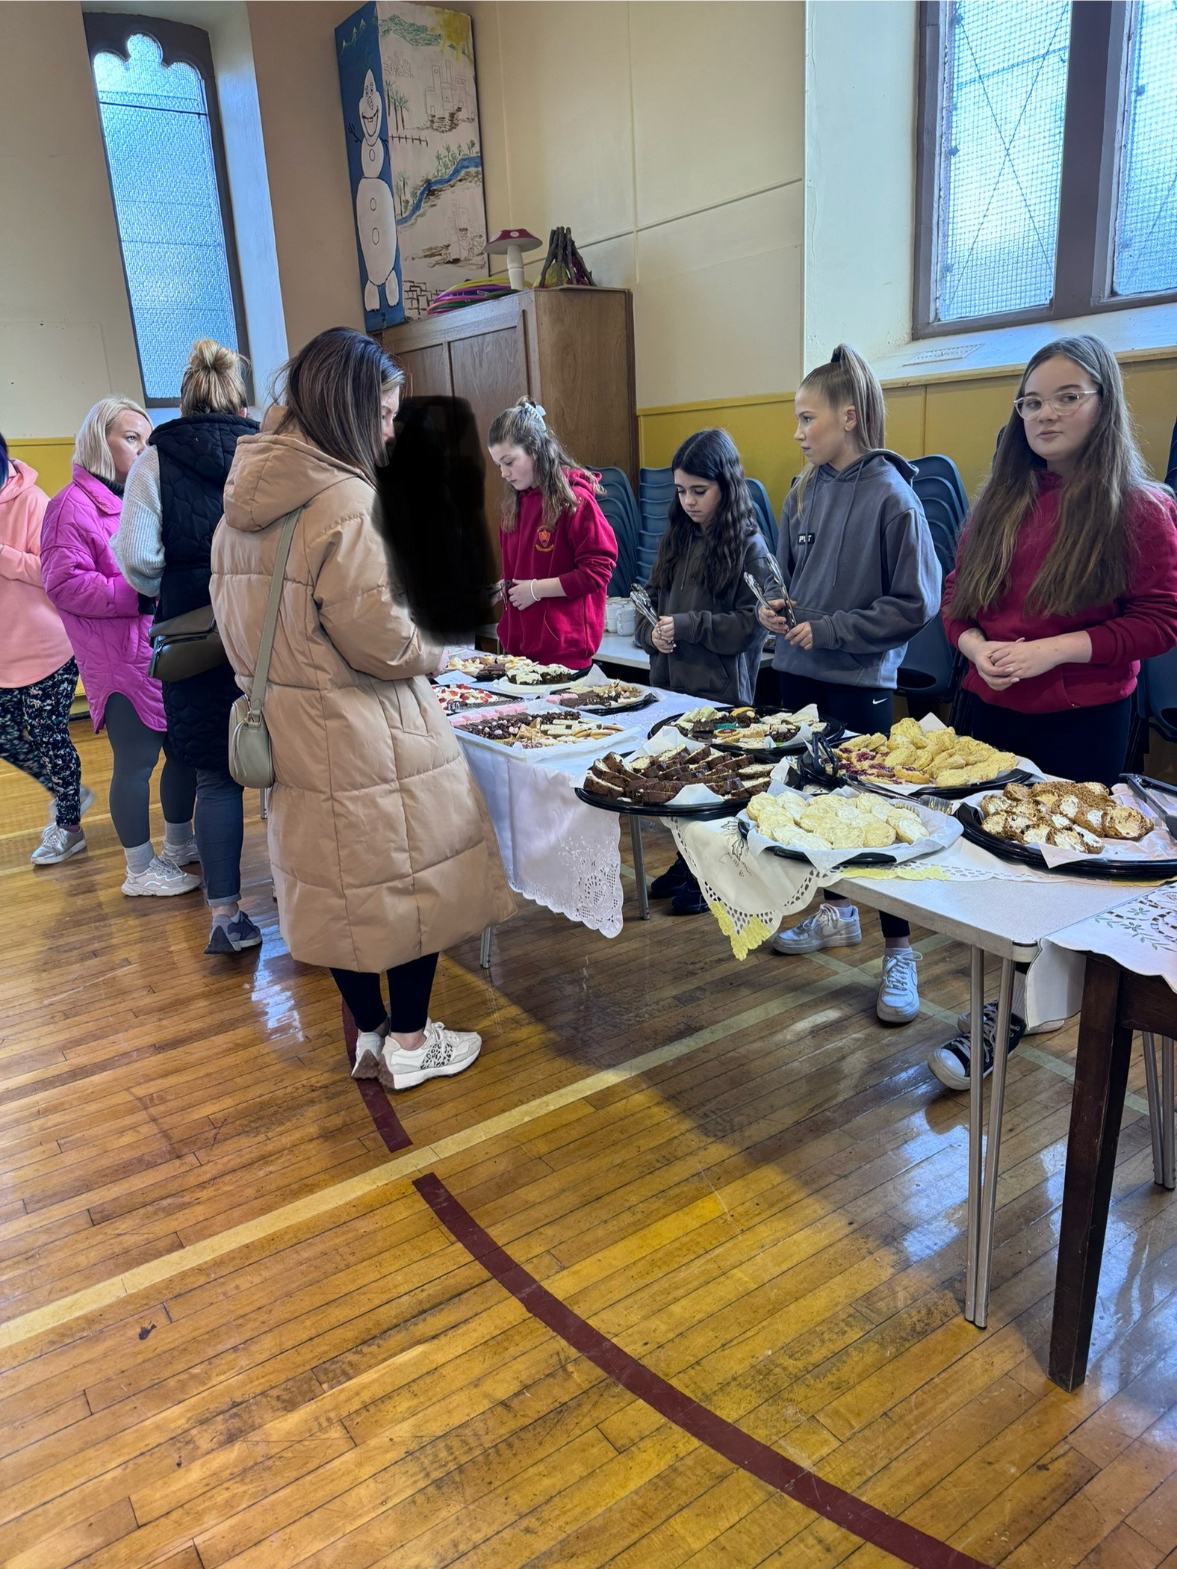
Mauchline Church Mens Club

The speaker for our January Meeting was Mr Jimmy Wyllie who gave an excellent talk on the History of the Curling Stone Works.
Jimmy is the 3rd generation of his family to produce curling stones.
The original curling stone works was at The Haugh Mauchline before moving to the present works in Barskimming Road Mauchline.
Jimmy gave an interesting insight into collecting granite from Ailsa Craig and shipping it to the mainland and described how the curling stones made in the factory are used worldwide and also used by all the curlers at the Winter Olympics.
The meeting was well attended and members enjoyed the talk.

A games night was enjoyed on February 14th.

On February 28th we had a joint meeting with the Guild.
Mr Bill Grant was the speaker for the evening who gave an entertaining light hearted talk on his 30 years in the Fire Service.

Future Meetings
March 13th Games Night
March27th Rev Bob Mayes
April 10th AGM
Come along and join our friendly group. We meet in the Church Hall.

Willie Jardine

The Guild

Treasurer’s Report March 2024

Total receipts Jan – Feb 2024 £12,643
Total expenditure Jan – Feb 2024 £10,191
Surplus Jan – December 2023 £2,452

There have been a few one-off expenses since the start of the year:
The hall floor was re-sealed at a cost of £1320
Plumbing work at the manse - £124
A new laptop was required for the livestream desk as the previous one stopped working - £349

Due to an issue at SSE Hydro with their systems, we have not had a bill for the gas in 2024 yet, so this means that we will have a few months to pay all at once when they can issue the next invoice.
Our contract with SSE Hydro is coming to an end so costs will most likely increase going forward.
Once again I would like to thank everyone who contributes regularly and for this I, as treasurer, am very grateful.
Yours in Christ
Elizabeth Morris
Treasurer
CHRISTIAN AID

Christian Aid Week this year will be held on 12-18th May 2024

Churches and supporters in Scotland raised over £640,000 for Christian Aid in 2023.
Quite a remarkable total, in a cost of living crisis.

This is a great opportunity for us as a congregation to get involved in helping our neighbours.

We could help fund the training that enables a community to form a village Saving & Loan association, that will support people to grow food, buy medicine and improve living conditions.

This year the focus is on Burundi where 70% of the population is poor.

It has been a difficult year again for many and Christian Aid certainly don’t take that for granted.
If you are able, please give to this wonderful cause, no matter how small.

Elizabeth Morris

MIDWEEK SERVICE

The Kirk Session has decided to start a short mid-week service.

This would be held monthly in the Hall at 2.00 pm
The next service will be on Wednesday 27.3.24.

If you are unable to come to a full Sunday service, you may feel you could come and enjoy a short time of worship, followed by a cup of tea and a time of fellowship.

If getting to the Hall would be difficult, don’t be put off. Speak to your elder, and arrangements could be made to pick you up, and take you to and from the service.

Everyone is welcome to come along.

Isabel Smith

CONGREGATIONAL REGISTER
Deaths

Mrs Mary Gilliland, c/o Temple House, Mossblown Died 12.1.24
Mrs Jean Weir, Glennie House, Auchinleck Died 31.1.24
Mr John Nicolson, ‘Elmwood’, Netherplace Died 27.2.24

Isabel Smith

Who’s Who & Where
Minister
Rev Dr Allan Vint, Mail: mailto:avint@churchofscotland.org.uk
Newsletter Editor:
Mr Jim Beck, Mail: mailto:mauchlineparish@yahoo.com

Dates for your Diary

Thursday 7th March - Marie Curie Daffodil Tea and Coffee Morning. 10 am to 12 noon in the Church Hall

Friday 26th April - Family Beetle Drive 6.30 pm in the Church Hall.
Tickets £3 each or £10 for a family (up to 6 people).

Woman's Day of Praise - Saturday 14th September 2024 - more details to follow.

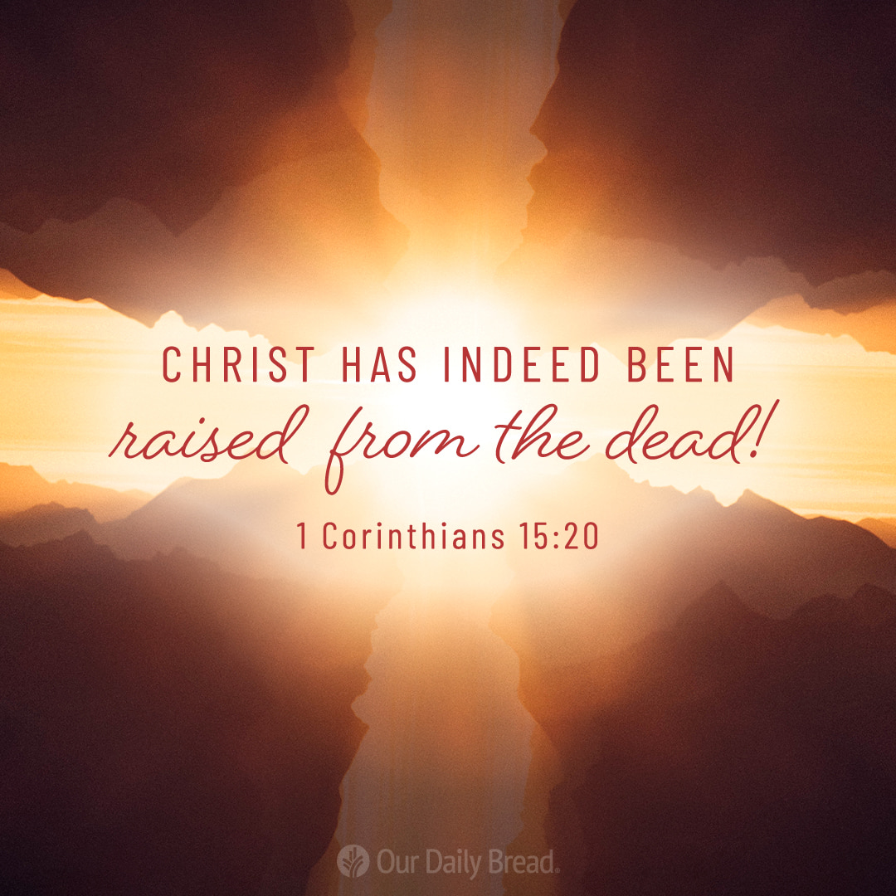
Footnote

