From the Minister – Rev Dr Allan Vint

It is the time of year when, in Scotland and around the world, much is spoken about the great Scottish bard Robert Burns. Of course, here in Mauchline there is perhaps greater attention given to him and his works since it was in these parts for many years he lived and matured in his gifting.
The man in life, wherever plac’d
Hath happiness in store
Who walks not in the wicked’s way
Nor learns their guilty lore!

Not from the seat of scornful pride
Cast forth his eyes abroad,
But with humility and awe
Still walks before his God

Paraphrase 1st Psalm Robert Burns

Besides being a local resident Burns was also a member of the church and subject to the good and bad of its time. As someone who paid close attention to the Bible (he knew it well), the church (being aware of its strengths and of its weaknesses) and of course church people (he was also keenly acquaint with human faults and failings – often from personal experience!) - meaning he had much to say about each.

In Christian beliefs Robert Burns was a moderate, aligning himself with the ‘New Licht’ outlook of some contemporary Church ministers. Those who took a more conservative, approach became the subject of some harsh words from the poet. For example, Robert expressed his dissatisfaction writing to a local minister (a New Licht) called Rev John McMath.
Epistle To The Rev. John M'math

But I gae mad at their grimaces,
Their sighin, cantin, grace-proud faces,
Their three-mile prayers, an' half-mile graces,
Their raxin conscience,
Whase greed, revenge, an' pride disgraces
Waur nor their nonsense.

None of us is perfect, this much is very true – the poet knew it in himself and was well able to highlight his own weaknesses and doubts.

He did however take exception to those who were hypocritical – putting on a display of piety and goodness whilst clearly being flawed in so many aspects of their life and attitude. Famously in ‘Holy Willie’s Prayer he pokes fun at such as these.
O Thou, who in the heavens does dwell,
Who, as it pleases best Thysel',
Sends ane to heaven an' ten to hell,
A' for Thy glory,
And no for ony gude or ill
They've done afore Thee!

I bless and praise Thy matchless might,
When thousands Thou hast left in night,
That I am here afore Thy sight,
For gifts an' grace
A burning and a shining light
To a' this place.

A section of Holy Willie’s Prayer

Robert Burns does us a favour by shining such a strong light on such things because it forces us all to take stock of our own life. What do I believe and why? Am I authentic and true or am I hypocritical? We might also ponder, like the poet, our own mortality and where we might be eternally destined, certainly it caused Burn to once pray
O, aid me with Thy help, Omnipotence Divine!

Messy Church

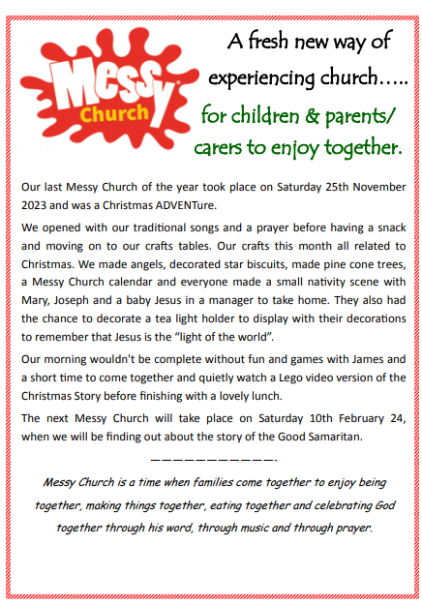

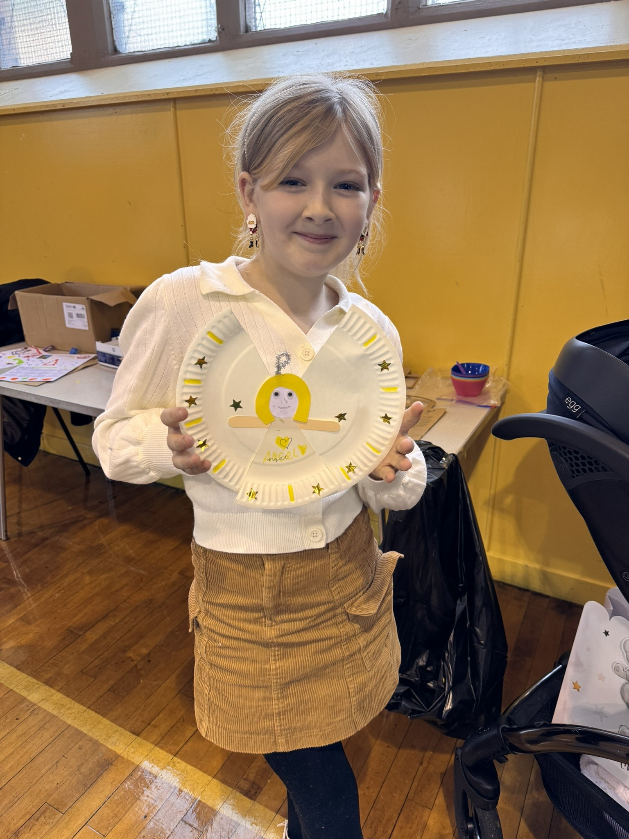


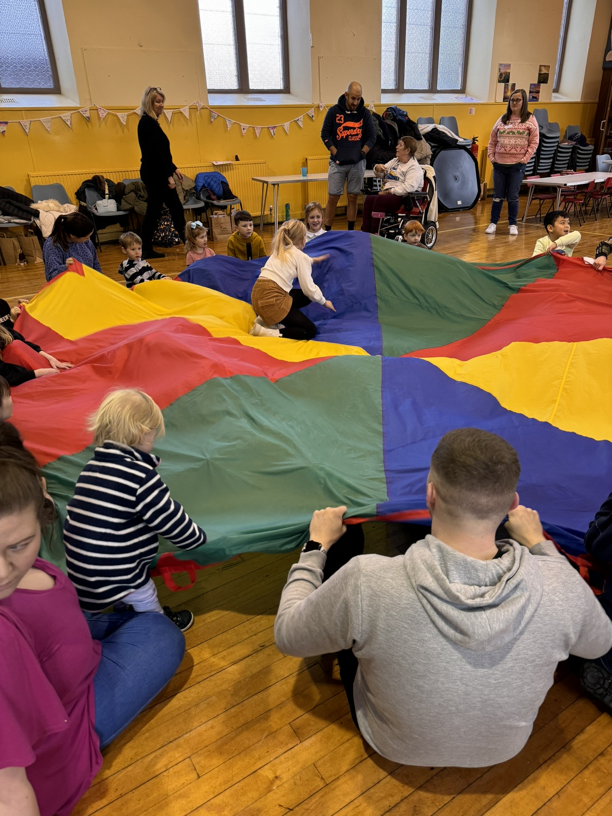
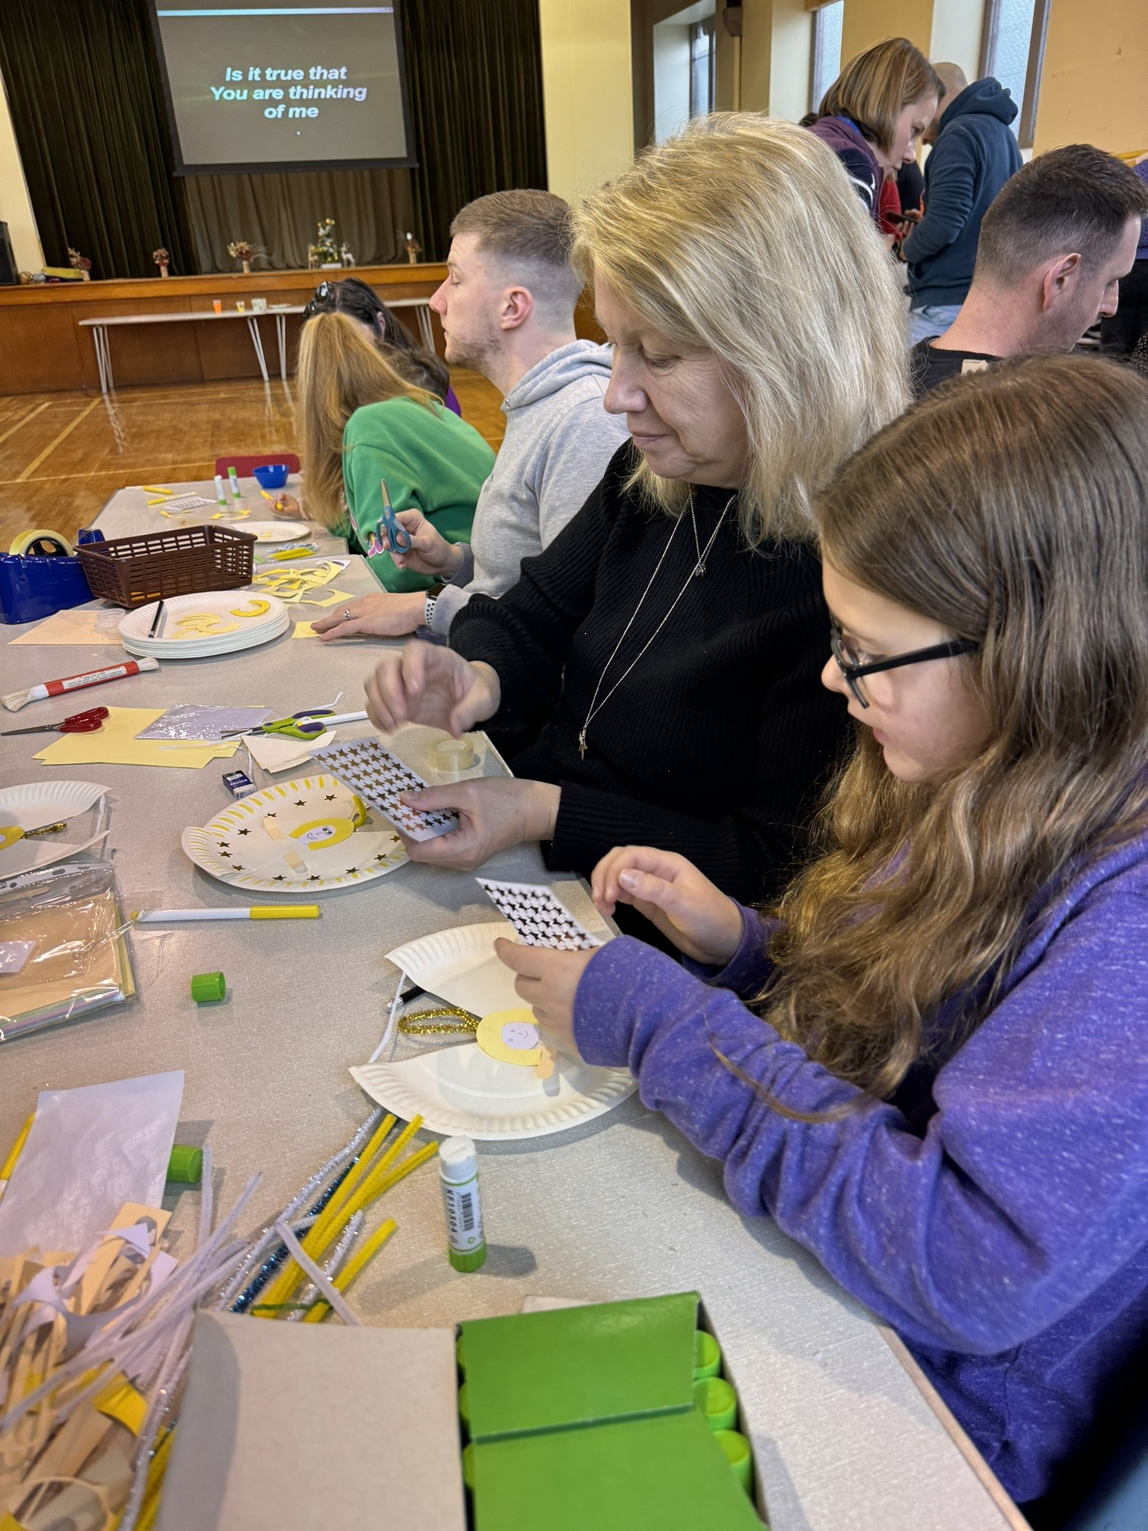

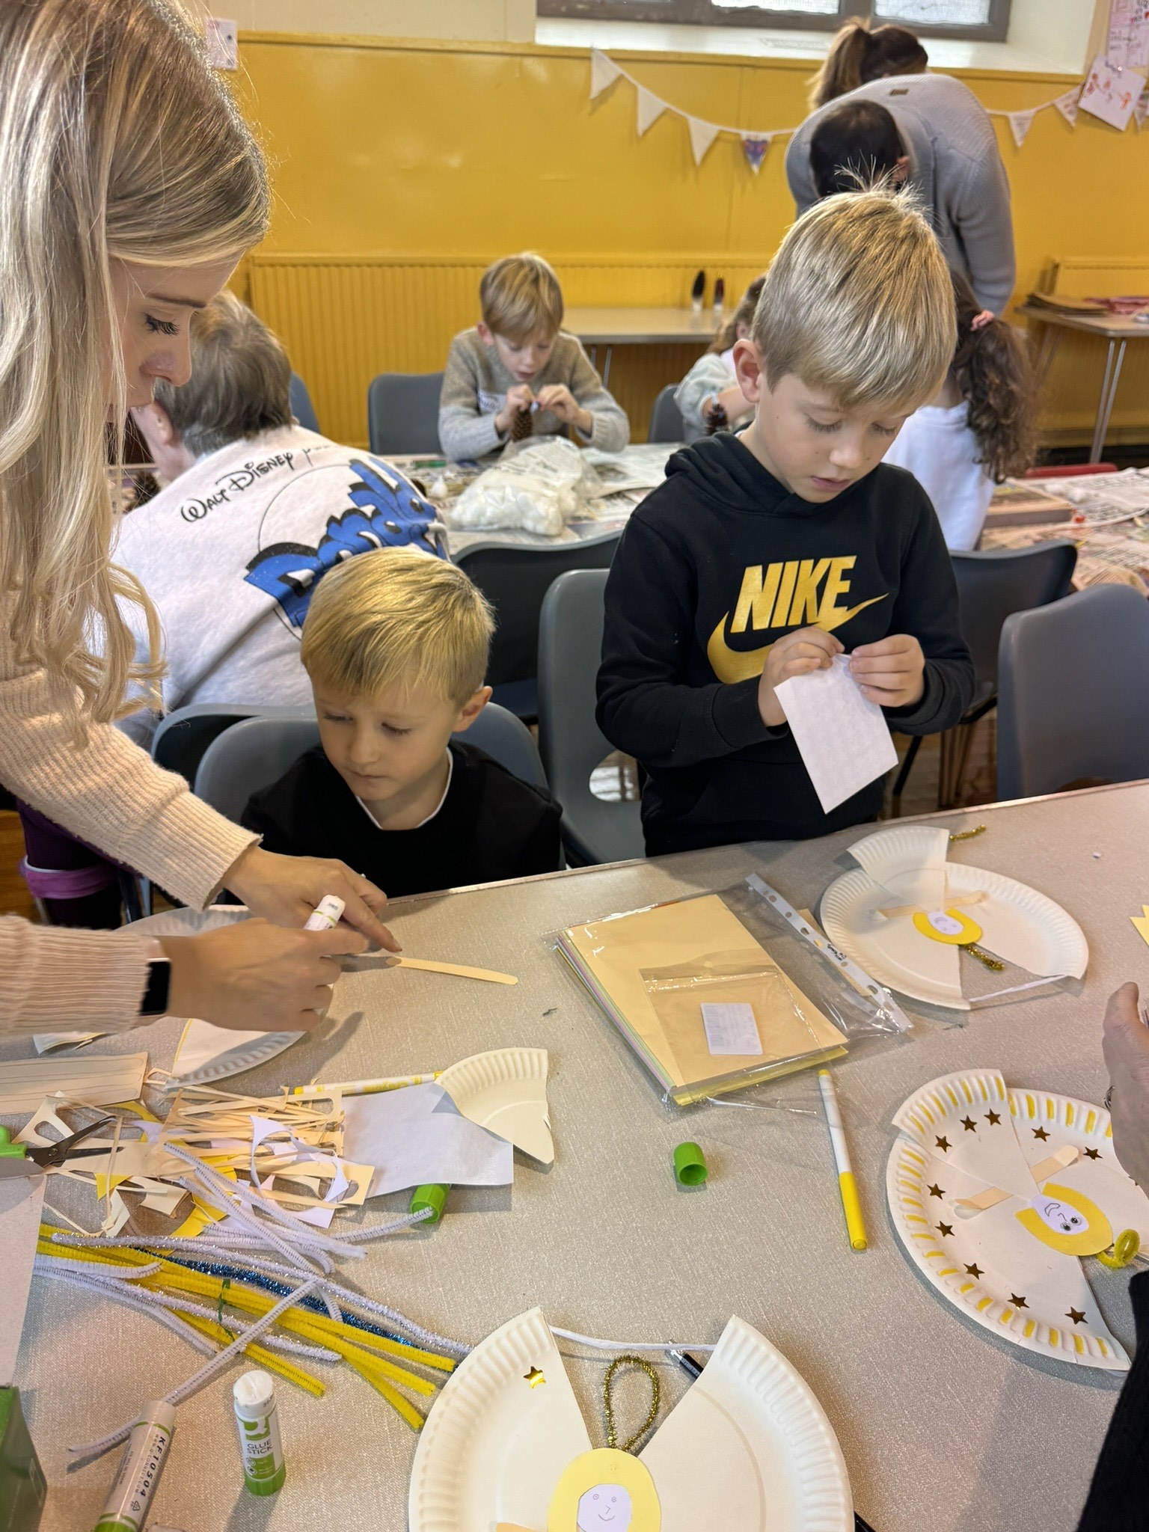
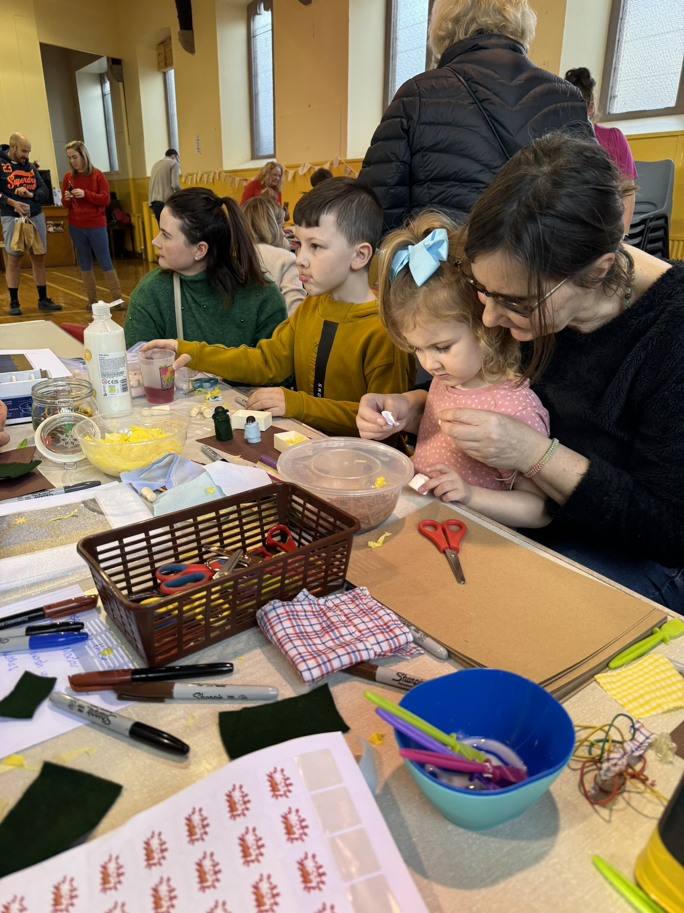

Nativity Services – Sunday 24th December 2023
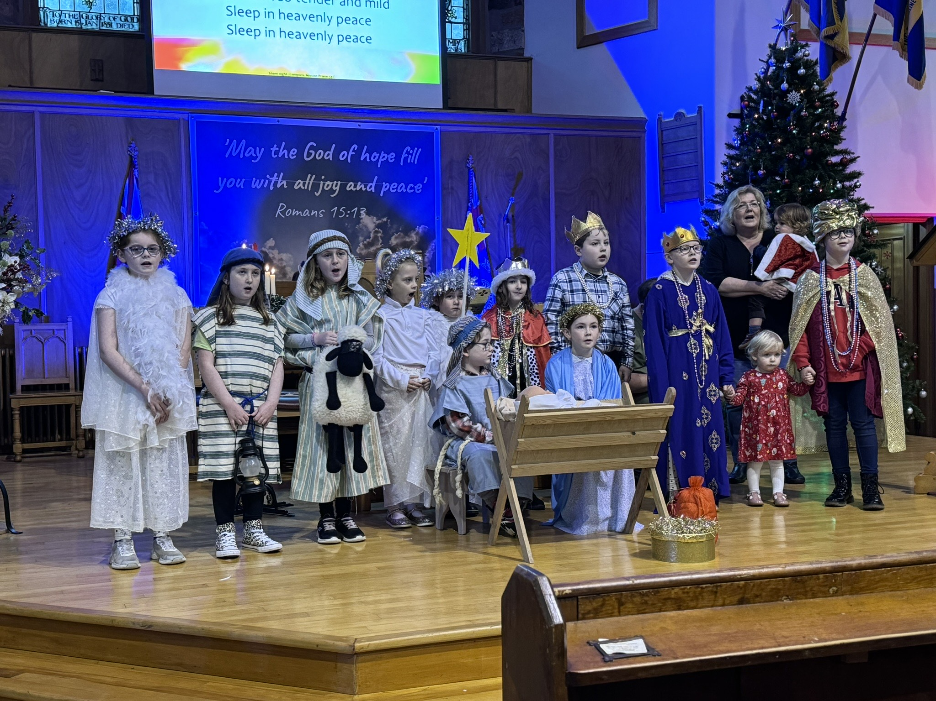
It was lovely to have children from the Messy Church and some Rainbows, Brownies and Guides in church on Sunday 24th December to take part in a short Nativity play. It is great to see the children develop an understanding of the Christmas Story and we were delighted to give them the chance to reproduce the story in church.
Thank you to all the children who joined us at both the 11am and 6pm services to perform the story and if you missed it you can still watch online on our Facebook page or YouTube channel.
Facebook: Mauchline & Sorn Congregations
YouTube: Mauchline and Sorn Churches (@mandschurches)

Mauchline Church Mens Club
Our November meeting with speaker Mr John Dale, a local solicitor, was very informative and John gave good advice on having made a will and the advantages of ‘ Power of Attorney’, which gave everyone food for thought.
An interesting light hearted insight into his career followed.


Kilmarnock Football Club Tour was the venue for our December outing and festive meal.
Twenty-three members enjoyed the tour and history of the football club.
We were pleased our past minister, Alan Telfer, could join us, as he has a particular interest in Kilmarnock Football Club. An excellent festive meal was enjoyed at the Park Hotel later.
During our well attended January games night, a minute's silence was observed in memory of the late Dr Keith Martin, a past president of the Men’s Club.
Future meetings:
January 24th Speaker Jimmy Wyllie ‘History of the Curling Stone Works’
February 14th Games Night
February 28th Evening with the Guild – Speaker Mr Bill Grant. “Light Hearted Talk on 30 Years in the Fire Service”
March 13th Games Night
March 27th Rev Bob Mayes
April 10th AGM

Please come along and join our friendly group.
Willie Jardine

Treasurer report January 2024
Total receipts Jan – December 2023 £88,106
Total expenditure Jan – December 2023 £71,313
Surplus Jan – December 2023 £16,793

The Church Ceilidh brought in £532 - it was a great night as well as raising funds for the church. Thanks to everyone involved.
Our Christmas Eve service raised £213 for our chosen charities this year, which were The Red Cross and Children’s Epilepsy Scotland. Thanks to all who gave to these worthwhile causes.
The final accounts for the year 2023 are currently being prepared so the figures above may alter slightly once everything is confirmed.
The surplus includes some one-off donations and a £10,000 legacy which have helped with finances this year. However going forward, this income is not guaranteed so income may be reduced in the coming year.
Our Energy contracts expired recently and the new rates are higher than previously (as is the case with everyone). Therefore our electricity and gas costs have increased in the last part of 2023 and into 2024.
Once again I would like to thank everyone who contributes on a regular basis and for this I, as treasurer, am very grateful.
Yours in Christ
Elizabeth Morris
Treasurer
FoodBank
The Cumnock food bank continues to be most grateful for all the contributions made from our church.

I would also like to say a huge thank you to all those who give in provisions, money and through prayer support. Everything is most welcome.

Donations of non-perishable foodstuff, toiletries, etc. can be left in the Clarke Memorial Vestibule.

Sheena

Calling All Surfers
Number of People Viewing Allan’s Sunday Mauchline and Sorn Live Streamed Services over the last weeks are:
2023 December 3(30), 10(45), 17(24), 24(65), 29(Dr. Keith Martin 278)
2024 January 7(44), 14(21), 21(), 28()

Who’s Who & Where
Minister
Rev Dr Allan Vint, Mail: mailto:avint@churchofscotland.org.uk
Newsletter Editor:
Mr Jim Beck, Mail: mailto:mauchlineparish@yahoo.com
Footnote


