From the Minister – Rev Dr Allan Vint

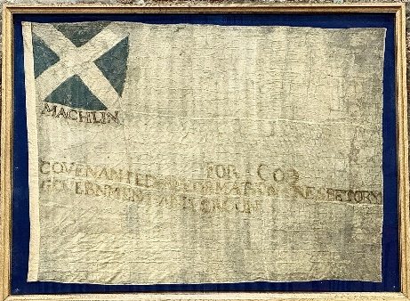
The 12th of June this year marks the 375th anniversary of the battle of Mauchline Moor. This event is remembered in Mauchline church through one of the local banners carried that day by one of the 2,000 strong ‘Kirk Party’ who demanded that Charles I accept the proper formation of the Presbyterian Church in Scotland and establish it in law. The opposing side from the Scottish Parliament Party (‘the engagers’) however, came up in force again this gathering and were victorious. Although the battle itself was lost, with a surprising low number of casualties, the Kirk Party went on to win the war, inspired surely by the courage of those who stood firm even against a superior force at Mauchline.
FOR GOD, COVENANTED REFORMATION PRESBETORY GOVERNMENT AND CROUN

Following the brutal execution of Charles I by Oliver Cromwell and his party, the Scottish nation was quick in calling upon the son of Charles to return from exile and be crowned King in Scotland. This took place at the hallowed ground of Scone Palace on the 1st January 1651. In England, Cromwell set up a Republic and wishing no opposition in Scotland invaded and captured Charles. It was only after the death of Cromwell and the inability of his son to control parliament that Charles eventually became king over all of the United Kingdom.

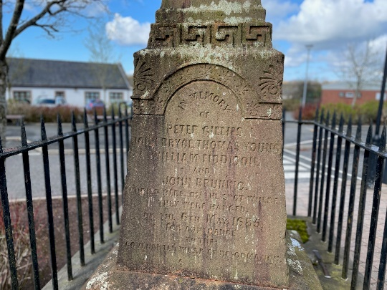
It might be imagined that Charles would look on the Scots as friends and allies, but in the interim period he had been turned against the Covenanters and so began a period of terrible persecution for all who held to the reformed covenanted cause. The many grave markers which are to be found locally are testament to the brutality of Charles II reign and James after him.

Thankfully with the eventual ascension of William and Mary to the throne, new laws and safeguards were put in place to protect the freedoms of the Church of Scotland to worship and to organise according to their interpretation of scripture.
Here lies the bodies of Peter Gillies, John Bryce, Thomas Young, William Fiddison, and John Bruning, who were apprehended and hanged without trial at Mauchline anno 1685, according to the then wicked laws for their adherence to the covenanted work of Reformation.
It is notable that as Charles III took up his position as king, he took an oath to continue those same hard won protections and indeed in his declarations at the time of his coronation, vowed to protect freedom of religion for all groups and communities.

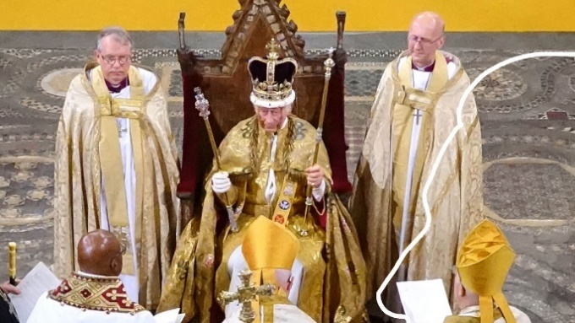
Today our fervent hope and earnest prayer is that King Charles III will remain true to his promises and indeed will prove to be a king who serves diligently following the example of Jesus – whom we hold as the King of Kings and Lord of Lords.
Photo: By Foreign, Commonwealth; Development Office, CC BY-SA 4.0, https://commons.wikimedia.org/w/index.php?curid=131676676

Sorn Guild
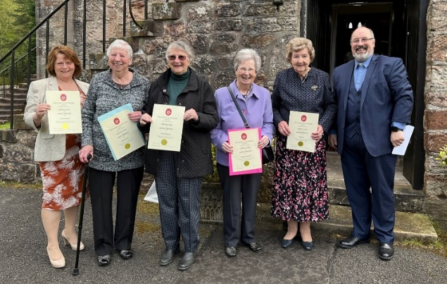
It was a joy on Sunday 7th of May to present long service certificates to five current members of Sorn Guild. The service periods ranged from 30 years to an astonishing 70 years ! 240 years in total. Well done ladies.

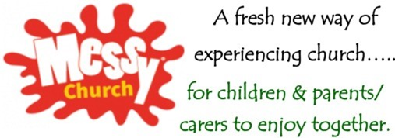
Messy Church is a time when families come together to enjoy being together, making things together, eating together and celebrating God together through his word, through music and through prayer.

In Messy Church we are a worshipping community of all ages, centred on Christ, showing Christian hospitality and having fun within a church context.

The second Messy Church was held on Saturday 1st April 2023. The theme for this day was New Life, with all activities based on the Easter message. There were 22 children and 12 adults attending everyone who came along had a fantastic morning and we had a lovely, friendly atmosphere in the hall.

Our next Messy Church will take place on Saturday 17th June where we will enjoy Coronation Celebrations while learning about who is King of Kings. Look forward to seeing you all there. Annette Milton
