From the Minister – Rev Dr Allan Vint
In the everchanging world of politics there is yet another leadership election. As I write, this current contest centres around who will be the next leader of the SNP and likely then to become Scotland’s First Minister.
In due course the result will be announced, and the individual will take on their new responsibilities – but only for a time. It may be weeks, months or years but, as sure as day follows night, they will eventually be replaced, and another will follow after them – such is the way of the world.
This Lent and Easter season is however a great reminder of another leader – one whose triumph was not at an election box – but of much greater significance and importance. Long ago Jesus contested against the powers of sin and death on our behalf. He took on an opponent whose aim was to bring us present misery and to destroy our future.
Jesus had behind him the backing of Almighty God, who longed for the time when his creation could again be free from the shackles of sin’s oppression and limitation. Jesus willingly took on the task of standing with us and for us. His leadership through life was inspirational, even awe inspiring, but it was nothing compared to his amazing servant leadership in willingly laying down his life for us, his people. Yes, Jesus died for us!
God demonstrates his own love for us in this: while we were still sinners, Christ died for us. Rom 5:8
More amazing still is the fact (and it is a fact undisputed by the agreed evidence) that he rose again. This was the proof that death had been defeated, that with Jesus a future had been won and that trust in Jesus would bring us not just temporary help but a secure eternity in his presence and love.
You may or may not have had a vote in this political leadership election, but we all have a decision to make with regards to the leadership of Jesus – will we trust him and follow him? Will we serve his cause and so enjoy the benefits he alone can bring. In this time of new beginnings, I would encourage everyone to consider carefully not only earthly things but the things of heaven.
May God bless you in this special season of Lent and Easter.
we fix our eyes not on what is seen, but on what is unseen, since what is seen is temporary, but what is unseen is eternal. 2 Cor 4:18

Mauchline Church Men’s Club

In December The Men's club enjoyed a tour of the Curling stone Works before our excellent Christmas Lunch at the Fairburn Hotel. Since then, we had a Games night and we've had an interesting talk from George English on Mauchline history.
An enjoyable games night took place on 8th February and on 22nd February we invited the Guild to join us for a talk by Stuart Lyons from Crossroads Hub. The Hub does a lot of community work in 6 Parishes along with running the excellent cafe and shop at the Hub. The informative talk was enjoyed by all. Our March Meetings include a Games Night (8th) and a History of the Haugh by Colin Campbell (22nd).

The session closes on 12th April with the AGM. We welcome all new and present members, meetings are held on 2nd and 4th Wednesday of the month in the Church hall at 7.30pm. Please come along and join our friendly group.

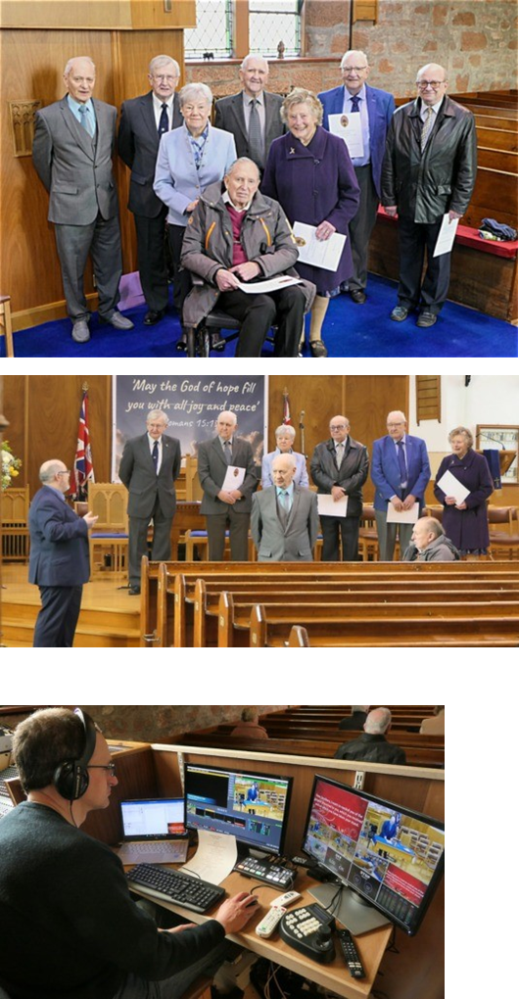
Long Service Awards

On Sunday 26th February and 26th March, Rev Dr Allan Vint presented Long Service Awards to elders who between they had amassed 389 years of service the church and the community here in Mauchline.

Graham Dick 40 yrs
Jean Martin 44 yrs
Keith Martin 44 yrs
Bob Mitchell 40 yrs
Anne Munro 40 yrs
Andrew Rae 40 yrs
John Templeton 45 yrs
Ian Watt 50 yrs
Russell Wyllie 50 yrs
(Mr John Templeton is absent from these photographs)

Church Online

You are invited to come and join us at Mauchline Church online. Each week our Sunday service is streamed live to Facebook and YouTube and then afterwards they remains available for viewing at your convenience.

Find us @ https://www.facebook.com/Mauchline.Sorn
https://www.youtube.com/@mandschurches
Website: www.mauchlineparish.org.uk
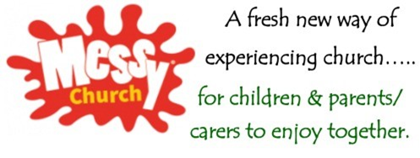
Messy Church is a time when families come together to enjoy being together, making things together, eating together and celebrating God together through his word, through music and through prayer.

In Messy Church we are a worshipping community of all ages, centred on Christ, showing Christian hospitality and having fun within a church context.
The Mission Committee decided to try this new venture for children in Mauchline and launched Messy Church on Saturday 11th February 2023.

The theme was “A New Start” and we learned all about Noah and how God gave the world a chance for a new start. The committee and volunteers were delighted to welcome 44 children and 20 adults to our first event, and along with 13 helpers and 4 kitchen staff.

The morning was filled with fun and laughter and lots of happy children.
We made animal masks, rainbow pictures, potato print animals, rainbow biscuits, animal bookmarks, rain sticks and enjoyed playing with toys and board games. After all these fun activities we came together to enjoy the story of Noah on video, sing some songs before all gathering in the Hall to enjoy lunch together.

The feedback we have received from the event has been very positive and we look forward to seeing the children and adults again on Saturday 1st April when the theme will be New Life and all activities will be based on the Easter Story

Worship Dates and Events April

- 1st 10-12.30pm Messy Church (Church Hall)
- 2nd 11:15am Family Palm Sunday Service
- 6th 7pm Maundy Thursday inc Communion @ Sorn Church
- 7th 7pm Good Friday Service @ Mauchline Church
- 9th 11:15am Easter Sunday Service

