From the Minister – Rev Dr Allan Vint
“Those who fail to learn from history are doomed to repeat it.”
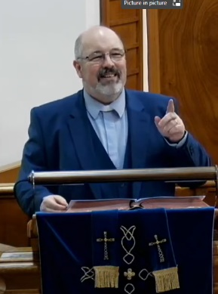
Sir Winston Churchill

It is with horror and with great sadness that we watch the unfolding of Russia’s invasion of Ukraine.
The resulting death, injury, many injustices, and the deprivations of ordinary people was always going to be the result of such a terrible action. As I write this piece for the church magazine, I hear many commentators draw parallels with Hitler’s actions and those of Putin.
Now you would imagine that in the run up to this situation the world would have responded more decisively to prevent it but that was not the case. Too many countries, too many leaders, too many people seemingly forgot that when evil is given an opportunity to control or to abuse then it seeks to make the most of it.
Hence it is always vital that we do what we can to stand up for what is right and good – which as Christians means following the example of Jesus - loving our neighbour, showing compassion, sharing mercy and working tirelessly for peace and justice.
It has been heartening to witness the tremendous solidarity being shown locally and worldwide for Ukraine and for Ukrainians. People everywhere have rightly demonstrated a huge outpouring of love towards the oppressed, the needy and of course the resulting refugees from this place of war.
Locally this was so evident in the huge outpouring of practical compassion and giving when it was announced that The Snug would provide a collection point for donations destined for refugees crossing into Poland.
To see the mountain of gifts was surely heart-warming amid such a dark moment in world history. Well done to all who gave, supported, organised and transported those provisions to those who need them.
In the Bible (Luke 10)
Jesus said, Love the Lord your God with all your heart and with all your soul and with all your strength and with all your mind; and Love your neighbour as yourself. But he was asked ‘And who is my neighbour?’ Jesus told them a story about a good Samaritan helping a man who had been attacked. He asks, who do you think was a neighbour to the man who fell into the hands of robbers? The expert in the law replied, The one who had mercy on him. Jesus told him, Go and do likewise.
Live Streaming
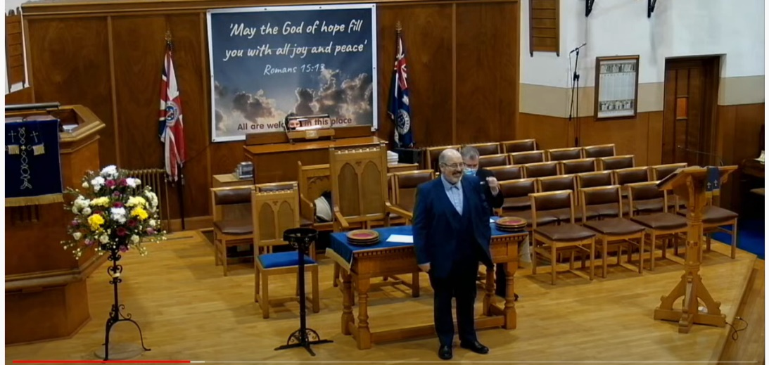
Our ability to Live Stream the service continues to improve, with extra equipment and a clearer focus. Thanks again to everyone who has helped make this happen, either by contributing financially or by volunteering to work the computer and cameras.
You can find our services live streamed at 11:15am on Sunday (and available on the afterwards to watch at your leisure)

https://www.facebook.com/Mauchline.Sorn or https://www.youtube.com/channel/UCPiMQjqez9yQ0-LlSUIultQ
(for longer version of the church magazine www.mauchlineparish.org.uk)

The Guild (Monday afternoons Church hall)
What a topsy turvy Guild Session this has been. Unfortunately, due to Covid restrictions being re-introduced we were unable to resume our planned January Guild meetings.
Thankfully in February we were able to go ahead and meet again. On 14th February we were delighted to welcome Roslyn Cartner as our speaker. Roslyn gave an excellent talk on diet and nutrition with many useful and helpful tips.
On 28th of February we were joined by four well known faces forming our panel namely Anne Munro, Sheena Davidson, John Templeton and Willie Jardine. Many varied questions were put to the panel members and they very ably gave their thoughts and opinions, at times causing much lively discussion and laughter.
It was indeed a very happy, uplifting meeting, much needed and appreciated amidst all the bad news currently on the go. We have two more meetings in March before the session (short as it has been) finishes.
On 14th March we will be joined by a speaker from “The Leprosy Mission”. At the end of the month we will have our Annual Business Meeting and this will be our closing meeting for this session. I have recently received some mailing about the new theme for the next session, which will I hope start at the end of September, but more about that next time.
All good wishes and blessings. Isabel Smith. Convenor
Mauchline Church Men’s Club
The Men’s Club met on 1st December which was an enjoyable games night meeting up with friends again. On December 8th fifteen members enjoyed an excellent
Christmas Lunch at the Fairburn Hotel getting us all into the festive spirit. Due to covid restrictions our next meeting was a games night on 9th February when it was good to play bowls and chat together again.
On 23rd February our minister Rev Allan Vint gave an excellent illustrated talk entitled Astrophotography – a journey out into the Cosmos which was an insight into distant galaxies and was a very interesting and informative evening enjoyed by all.
A games night is on Wednesday 9th March at 7pm in the Church Hall.
We are a friendly group and warmly invite any men to join us in the Church Hall on the second and fourth Wednesdays of the month. For more information contact president Willie Jardine or vice president Ian Watt or any Men’s Club member. Willie Jardine
Shoppers’ Lunch
The church is planning to resume this wonderful service from Thursday 17th of March.
Everyone is welcome to come along to the church hall between 11:30am and 1:30pm, on the third Thursday of each following month, where there will be an opportunity to meet with friends and enjoy some homemade soup and filled rolls/sandwiches. Proceeds go to church funds.
Christian Aid Week
Christian Aid week is from 15-21 May 2022 and this gives us an opportunity to contribute to the work of this organisation. As you are aware Christian Aid is very much at the forefront of dealing with disasters and emergencies and also climate change. It is therefore vital that we, as a congregation and community continue to support them in this work.

